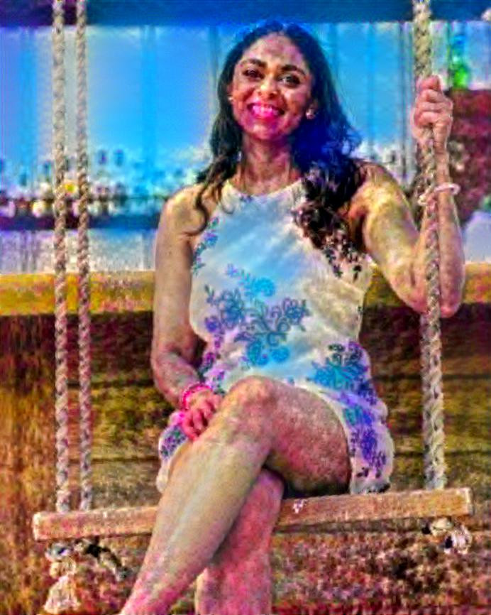

The first picture is of me with oranges in the background since I love to cook and that is what represents me. I am always finding new recipes and new hacks that I like to share with my friends. I even published my own cookbook this summer! I also have an autoimmune disease so cooking has been a love for me especially since I cannot enjoy food within a restaurant. The second picture is what people see me as and that’s… Indian. The second picture is of me merged with Holi the Indian festival of colors. While I am Indian I do believe that it is a huge part of my identity and how people see me like most people. We all have our own preconceived notions about who people are based on where they come from. I view myself as someone who is always smiling and has a good heart. When we understand **Artificial and Real** I believe it’s something we can even perceive within ourselves and how we view people. In a way, we sometimes make our actions artificial in hopes that we fit in with a group or crowd instead of just being real and honest.